FIVE DOCK RSL ORCHID SOCIETY INC
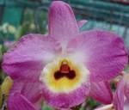
Dendrobium Five Dock Fire ‘Summertime’
Committee Nomination Form

Nominated Position:

Nominee’s Name: Signature Print Name

Proposer: Signature Print Name

Seconder: Signature Print Name

Declaration of nomination acceptance by nominee

I, do agree to accept the nomination for the
position of .

Nominee’s Signature: Signature

