FIVE DOCK RSL ORCHID SOCIETY INC APRIL 2026 BULLETIN
Meetings are held on the 4th Thursday in the months of January to November.
at Concord Community Centre, 1A Gipps Street, Concord, NSW 2137
The Society was founded on 19th July 1967.
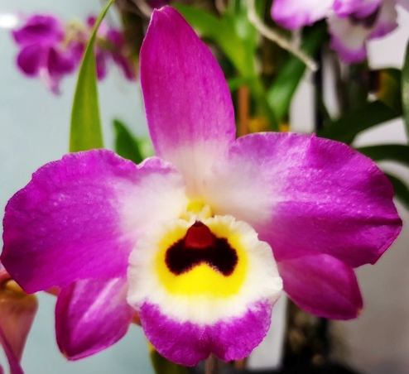
Society Emblem: Dendrobium Fivedock Fire ‘Summertime’
Next meeting will be held on Thursday 23rd April 2026 commencing at 7.40 pm
Five Dock RSL Orchid Society is proudly supported by.
Club Five Dock RSL, Canada Bay Council and MarketPlace Leichhardt Shopping Centre
Visit our website www.fivedockorchids.com & our Facebook page Five Dock RSL Orchid Society for photos of the winning orchids from our Monthly Meetings and Annual Shows, Plants of the Night, Class winners, Show Champions, and record of our Social Events.
Website Coordinator: Jane D’Olier
PATRON: Robert Ridge
PRESIDENT: Fedora Pristov
VICE PRESIDENT: Kathy Koutsoukis
SECRETARY: Robert Moon Mobile: 0412 335 349
Society Email: fivedockrslos@yahoo.com.au
Postal Address: PO Box 4035, Bradbury NSW 2560
TREASURER: Fedora Pristov
SHOW MARSHAL Peter D’Olier
COMMITTEE: Jane D’Olier Sharon McIlwain Robyn McEwen
Peter D’Olier Merv Maher Jonathan Tran
President’s Report
I would like to thank all the members for electing me as your President for 2026-2027. I am truly honoured to be your President.
At the end of March, we had our Annual Barbeque, where thirty-four members attended. The day had perfect weather, excellent chefs, and a great raffle. I would like to thank all the ladies & Robert for supplying the desserts.
As I write this report, we have set up our Annual ANZAC Tribute Display and thank you to all the members that have supplied their plants for the display. The display is outstanding and photographs will be on our website with thanks to Jane D’Olier.
Jonathan Tran won the grand champion with Dendrobiums Margaret Fell. With Reserve champion going to Sharon McIlwain with Miltonia spectabilis ‘Big Ben’ congratulations to all the winners.
We are always happy to support Club Five Dock RSL with the display and to participate on Sunday with the wreath laying.
Remember our Autumn / Mother’s Day show set up at Leichhardt Marketplace will be from 4pm Wednesday 6th May 2026 with Judging from 9 am on Thursday 7th May 2026 with Pull down from 4pm Saturday 9th May 2026. At our meeting, a Roster for duty at the show and we need as many members as possible to make the show a success.
We are arranging our annual Bus trip to Mingara Orchid Fair for Saturday 27th June 2026 and more details will be available at our next meeting.
Finally on behalf of the Members & Committee we wish our hard-working Secretary, Robert a very Happy 70th Birthday
Looking for your ongoing support Fedora Pristov

FIVE DOCK RSL ORCHID SOCIETY INC
Minutes of the Monthly General Meeting held on 26th March 2026,
at Concord Community Centre, 1A Gipps Street, Concord
Opening:
The Vice President declared the meeting open at 7.40pm and welcomed all members and our guest. Fedora then requested all those present to either turn their mobile phones off or to silent.

Apologies:
Apologies were as listed on the attendance sheet.

Minutes:
It was moved that Minutes of the meeting held on 26th February 2026 as circulated, be adopted as a true and correct record of that night’s proceedings.
Moved Alonya Cullinan Seconded Sam Campagna Carried

Business arising:
There was no business arising from the minutes.

Treasurer’s Report:
Fedora tabled the treasurer’s report including accounts for payment
Moved Judy Major Seconded Geoff Orme Carried

Correspondence:
The summary of Correspondence received, was tabled. Consisting of various Orchid Society Newsletters, News on upcoming Orchid Events & Conferences, Open Gardens information from the Garden Clubs Australia and promotions of various “Orchid & Garden” tours.

General Business:
The Vice President asked had everyone present had signed the attendance register for insurance purposes, Covid 19 tracing, and the lucky badge draw

Fedora advised Robyn McEwen condition had improved

Members were advised all Growing competition plants Npp Woody’s Surprise ‘Double’ x Zga Freestyle Meadows ‘River Gum’ which Scott has registered with Kew as Neopabstopetalum (Npp) Memoria Margaret Reavell to honour our late Treasurer. Two plants are being kept for Margaret’s Siblings as a reminder of her.

The Vice President advised the wide range of raffle prizes and to please support the raffle by buying tickets

A reminder that our Annual Barbeque / Picnic Day is at Kokoda Track Memorial Walkway Weather shed which will be held this coming Sunday 29th March 2026 starting from about 10am Meat & Salad will be provide with Tea & Coffee & Soft Drinks if you want something stronger please BYO also disposable Plates & Cutlery will be available but it is suggested you bring something more durable to eat off and metal cutlery and drinking utensils. We would request you bring something for dessert to have with Tea & Coffee after Sausages & Kebabs Yes there will be vegetarian options.

Reminder that our Anzac Tribute Display will be 18-19th April 2026 setup on Saturday from 10am to 11.45am. With judging from 12 noon and tear down on Monday 20th April 2026 from 10am. Show schedule & benching sheets attached to March 2026 Bulletin

General Meeting was suspended to hold the Annual General Meeting and that the President & Treasurer’s Annual Reports could be presented and the Election of Office Bearers for the year 2026-2027 be held.

President’s Annual Report:
As I look back on the last 12 months, I am happy to report that Five Dock RSL Orchid Society is moving forward after an extraordinarily successful year.
We started off the year with our BBQ Picnic Day. This is an opportunity for members to enjoy good food and good company. The men did the cooking; the women did the salads and members contributed lots of lovely cakes and sweets to have with tea and coffee. And this year's BBQ is only a few days away!

In April we held our Anzac tribute at Club Five Dock RSL and attended the Anzac service at Five Dock Park. This is a tradition we do every year to show our respect.
Many saw us at Marketplace Leichhardt doing our Autumn/Mother's Day show, which was very successful. August saw us at the Ferragosto Festival in Five Dock. Club Five Dock gave us our own stall so we could promote our Orchid Society to the many people who attend the festival.
September saw us back at Marketplace Leichhardt for our Spring show which was another immense success.
October saw us as part of the Orchid Central Show at Condell Park. This show is gaining momentum and is becoming extremely popular.
We wound up the year with our fabulous Christmas Party in the ballroom at Club Five Dock RSL. Great company, great food, and great raffles.

On top of these shows and activities we also had several friendship nights at Club Five Dock RSL. Fedora and I held talks on Orchids at Bunnings Gladesville & Rydalmere.
We also took part in the Spring Launch at both stores and enjoyed doing their garden clubs.
Behind the scenes we have a very hard-working committee and their hard work has continued to make our society grow.

First of all, I would like to thank Fedora Pristov for all her work as Vice President and acting as our treasurer due to the sad passing of Margaret Reavell.
Fedora also provides supper at our meetings, attends Bunnings with me for the garden club and chairs our meetings as I judge.
Next, I would like to thank Robert Moon, our secretary, who put up with all my queries. Robert prepares our monthly bulletin and keeps us abreast of all our correspondence and things that need taking care of to keep the society running smoothly.
Peter & Jane D'Olier give so much to our society not only by judging at our monthly meetings but also the photography, the point score and the website. They have many other commitments but always find the time for Five Dock. Peter is also our Show Marshall.
Sharon McIIwain is a strong member of our committee. Sharon put her hand up to organise the volunteers for the Orchid Central show and is doing the judging course so we will have another judge in the future. Sharon always puts her hand up to help in any way.
Another strong member of our committee is Jonathan Tran. Jonathan will do anything to help whether it is stepping up to do supper, helping at Bunnings Spring launch, or helping in any way he can at our shows.
Then we have Merv Maher, who is at the hall every month putting out the tables and chairs and helping at our shows. Finally, we have Robyn McEwen who does the supper and helps at our shows, and at Bunnings Spring shows and garden talks.

I want to thank the committee for all the support I have been given in my time as President of Five Dock RSL Orchid Society. It has been a privilege to serve as president.

Treasurer’s Annual Report:
The Acting Treasurer tabled the report and asked if there were any questions about the report and advised that copies of the Statement were available, and she would be available to answer further questions after review.

Fedora then asked Marianna Patchett to function as returning officer on this occasion.

The Returning Officer advised that nominations for the various position had been received in accordance with our constitution and that there was no legal impediment to any of the persons standing for election. Marianna then asked for any further nominations from the floor.

There being no further nominations received, and there being no need for a ballot for any position, the returning officer put the matter to the members for their approval. The matter was put to the members and there being no objections, the Returning Officer declared the following persons elected to the positions for the year 2026-2027.

Office Bearers are:
PRESIDENT: Fedora Pristov
VICE PRESIDENT: Kathy Koutsoukis
SECRETARY: Robert Moon
TREASURER: Fedora Pristov
Committee Members are:
Jane D’Olier Peter D’Olier Merv Maher
Robyn McEwen Sharon McIlwain Jonathan Tran

Fedora thanked Marianna for her assistance. Marianna then wished the new committee well, for the ensuing year.

Resumption of Standing Orders:
The monthly meeting for March 2026 was resumed

Supper:
The meeting broke for Super

Lecture
Fedora introduced Gary Hodder and his presentation of Problems associated with growing Orchids
Gary started by advising there are various pest such as Sap sucking ones Scale, Aphids, White Flies, Mealy Bugs, Thrips and Spider mites and advised against using Confidor as it is harmful to bees. Next are the chewing pests Snails, Garlic Snails in particular & Slugs that have a Radula ( sharp grinding like “teeth”) to “file” there way into the leaf and don’t need to start at an edge whereas Caterpillars need to start at an edge similarly Cockroaches, Grasshoppers and the dreaded Dendrobium Bettel and even rats & mice.

Other things such as cold wet conditions cause leaf damage and even sunburn. Salt toxicity can harm plants through chemical fertilisers & missing Trace elements. Gary advised a tiny hole in shadecloth had allowed direct sun on a leaf and caused major damage. Gary spoke how organic fertilisers are better for the environment rather than Chemical. Damp conditions can lead to mould and fungal problems naming several including Phytophthora

Gary finished with various Viruses and advised there are believed to be thirty-three viruses in the Sydney region and named the most prevalent Mosaic, Ringspot & Rhabdo viruses. There are test kits available from Barrita to test the main viruses but alternatively It is recommended to send samples via express post to reduce the time in transit. To arrange for testing, contact Peter Cross at Peter.Cross@dpipwe.tas.gov.au or visit the website: https://nre.tas.gov.au/biosecurity-tasmania/plant-biosecurity/plant-diagnostic-services.

The best option is to practice good hygiene plants can not get rid of viruses like animals. Infected plants must not be composted but placed in Plastic Bags and disposed of.

Lucky Badge Draw:
Was won by Philip La

Raffle:
Winners were Judy Major, Louisa Campagna, Fedora Pristov, Marianna Patchett, Richard Oppendosano, Craig Scott-Harden, Sharon McIlwain, and Mark Grffith

Closure:
The President then closed the meeting at 9.25 pm thanking members for helping supper, wished everyone a safe journey home, and asked for help to put the tables & Chairs away & vacuum up spilled potting media.

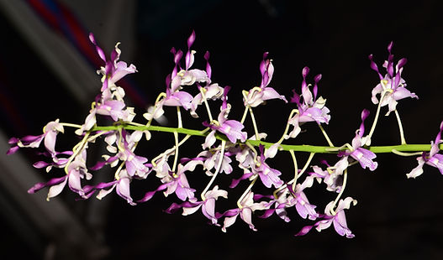

Open Plant of the Night March 2026
Den Speewah Twist
Owned By Peter & Jane D’Olier

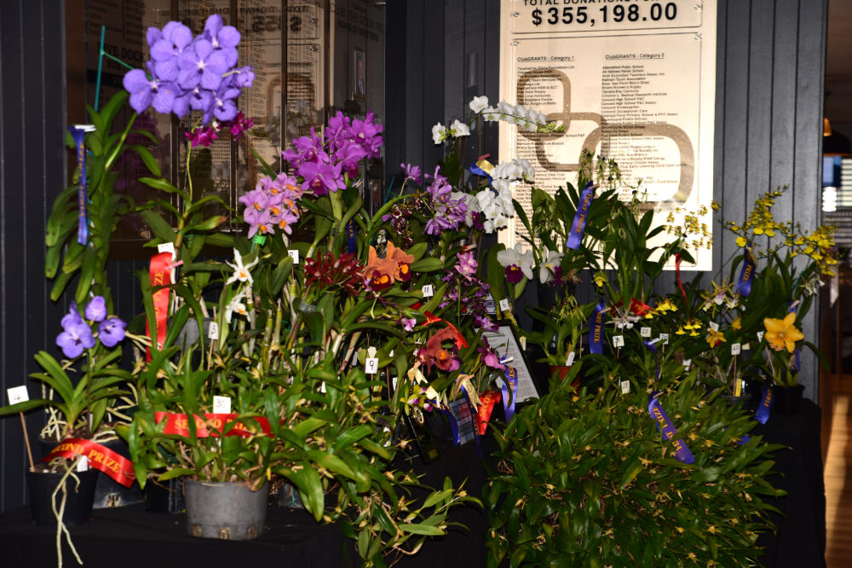

Anzac Tribute Display April 2026 Club Five Dock Foyer

Point Score March 2026
Open
Class 3 Laeliinae (Cattleya) Exhibition |  | Class 22 Oncidiinae under 35mm
1. Rlc. Pamela Mench ‘Yellow eye’ | P. La | 1. Onc. Sharry Baby 'Sweet Fragrance’. | S & L Campagna
2. C. Dal’s Choice ‘Rudak’ x Rlc. Brunswick Gem ‘Coral’ | K. Koutsoukis | 2. Oncsa. Liz Woolf ‘Lizzie’ | K. Koutsoukis
Class 4 Laeliinae (Cattleya) 66-110mm |  | Class 23 Oncidiinae 36-60mm
1. Ctt. Topaz Saucy 'Really Pretty’ | P. La | 1.Colmanara Wildcat ‘Bloodshot’ | G. Hodder
2. C. Fire Magic ‘Rosella’ | J. Tran | 2. Ons. Everglades Elegance 'Nancy Lee’ | S & L Campagna
3,Rlc. Waianae Leopard 'Ching Hua’ x Slc Jungle Treasure Mojave | S & L Campagna | Class 24 Oncidiinae over 61mm
Class 6 Laeliinae (Cattleya) Cluster 5+Flowers |  | 1. Milt. Leucoglossa | S & L Campagna
1. Ctt. Topaz Saucy ‘Hot” | J. Tran | 2. Bcd. Gilded Tower 'Mystic Maze' | S. McIlwain
2. Ctt. Gerard Nappert ‘Sophie’ | J. Tran | 3. Milt. Leucoglossa | S. McIlwain
3.Rth. Rosella's Lovely Sunset | J. Tran | Class 26 Species Asia
Class 7a Laeliinae (Cattleya) Species |  | 1. Bulb. biflorum | P & J D’Olier
1. C. bicolor | J. Major | Class 27 Species Other Areas
2. C. bowringiana 'Black Prince’ | P. La | 1. Angcm. distichum | P & J D’Olier
3. C. bowringiana | S. Thompson & T. Balgos | Class 28 Miscellaneous Hybrids not Listed
Class 7b Laeliinae Species Other than Cattleya |  | 1. Z. Jumpin Jack | C. Scott-Harden & A. Cullinan
1. Psh. cochleata | S & L Campagna | 2. Epi. prismatocarpum x Epi. radiatum | P. La
2. Psh. cochleata ‘Pepe’ x Psh. cochleata ‘Jules & Elaine’ | S. McIlwain | 3. Z. Arthur Elle | R. Oppedisano
3. Epi. ibaguense, | G. Hodder | Class 32 Australian Epiphytes Hybrids
Class 9 Paphiopedilum Other |  | 1. Den. Brimbank You Beauty x Den. Born to Star ‘Darkness’ | C. Scott-Harden & A. Cullinan
1. Paph rothschildianum x (James Bacon x Tokyo Black Knight) | C. Scott-Harden & A. Cullinan | Class 36 Australasian Hybrids
2. Phrag ‘Unknown” | C. Scott-Harden & A. Cullinan | 1. Den. Speewah Twist | P & J D’Olier
Class 12 Dendrobium Species (Not Australasian) |  | Class 48 Seedling
1. Den. annae, | G. Hodder | 1. Den. Baby Happy Holidays, | J. Tran
Class 14 Monopodial/Vandaceous Hybrids
1. Van. Fuchs Ocean Spray | F. Pristov
Class 15 Coelogyninae Species
1. Coel. usitana | P & J D’Olier | Novice
2. Coel. Multiflora | P & J D’Olier | No benching
3. Ddc. magnum | P & J D’Olier
Class 19 Pleurothallidinae Species
1. Pleurothallis tuerckheimii | C. Scott-Harden & A. Cullinan
2. Stelis porschiana | P & J D’Olier
3. Rstp. wageneri | P & J D’Olier
Class 21 Oncidiinae Species
1 Milt. spectabilis ‘Big Ben’ | S. McIlwain
2.Milt. clowesii | J. Tran
3.Onc. flexuosum | S & L Campagna | Number of Plants Benched =53

ANZAC Tribute Results
Grand Champion | Den. Margaret Joan Fell | J. Tran | Champion Cattleya | Rlc. Dewy Forest 'Blumen Insel’ | N & D Tzelis
Reserve Champion | Milt. spectablis ‘Big Ben’ | S. McIlwain | Champion Dendrobium | Den. Margaret Joan Fell | J. Tran
Champion Species | Milt. spectablis ‘Big Ben’ | S. McIlwain | Champion Oncidiinae | Oncid. Sweet Sugar | S & L Campagna
Champion Hybrid | Den. Margaret Joan Fell | J. Tran
Open Classes | 1st |  | 2nd
1. Cymbidium | No Benching
2. Laeliinae (Cattleya) – Mini up to 65mm | Ctt. Chief Berry | N & D Tzelis | Rly. Swan’s Shy | S & L Campagna
3. Laeliinae (Cattleya) – 66 – 110mm | C. Mari's Love ‘Taka' | K. Koutsoukis | Rlc. Aussie Bottler ‘Janelle’ | J. Tran
4. Laeliinae (Cattleya) – Cluster 5+ Flowers | Ctt. Porcia 'Cannizaro' | P. La | Ctt. Towering Inferno ‘Geoff’ | J. Tran
5. Laeliinae (Cattleya) – Exhibition | Rlc. Dewy Forest 'Blumen Insel’ | N & D Tzelis | C. Chyong Guu Swan | J. Tran
6. Laeliinae (Cattleya) – Species | Psh. cochleata | S & L Campagna | Psh. cochleata | P. La
7. Dendrobium Species (Not Australian) | No Benching
8. Dendrobium Hybrids (Not Australian) | Den. Margaret Joan Fell | J. Tran | Den. King Dragon Princess | J. Tran
9. Cypripedioideae Species & Hybrids | Paph. primulinum | J. Tran
10. Monopodial / Vandaceous Species & Hybrids | V. ‘Unknown’ | S & L Campagna | V. Sansai Blue | P. La
11. Coelogyninae Species & Hybrids | Coel. ovalis | J. Tran | Coel. ovalis | N & D Tzelis
12. Phalaenopsis Species & Hybrids | No Benching
13. Pleurothallidinae Species & Hybrids | No Benching
14. Oncidiinae Species | Milt. spectablis ‘Big Ben’ | S. McIlwain | Oncid. flexuosum | S & L Campagna
15. Oncidiinae under 35mm | Ondont. ‘Honey Bee’ | S. McIlwain
16. Oncidiinae 36-60mm | Oncid. Sweet Sugar | S & L Campagna | Odcdm. Everglades ‘Nancy Lee’ | S & L Campagna
17. Oncidiinae over 61mm | Brat. Dennis Kleinbach ‘Crowhurst' | J. Tran | Brat. Aztec 'Toni' | F. Pristov
18. Species America | No Benching
19. Species Asia &amp; Other | No Benching
20. Miscellaneous Hybrids – Not listed. | No Benching
21. Australasian Species | No Benching
22. Australasian Hybrids | No Benching
23. Specimen Minimum of 5 Racemes | Coel. ovalis | J. Tran
Novice Classes
24. Novice Hybrids | No Benching
25. Novice Species. | No Benching

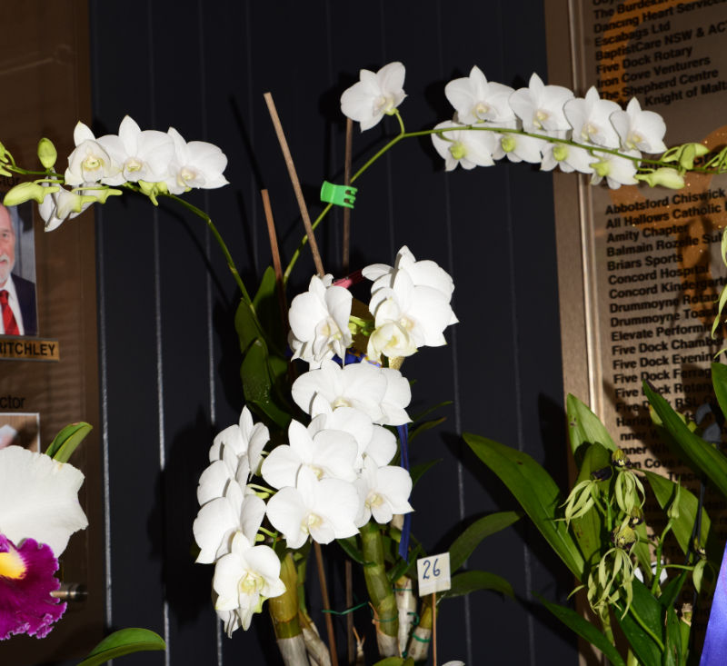
Anzac Tribute Grand Champion Den Margaret Joan Fell Owner Jonathan Tran

Dates for the Diary
06th May 2026 Autumn Show Marketplace Leichhardt to 9/5/2026
15th May 2026 Orchids Out West, Clarendon to 17th May 2026
28th May 2026 Monthly Meeting / Growing Competition Judging
09th June 2026 Friendship Night @ Club Five Dock RSL
25th June 2026 Monthly Meeting
27th June 2026 Bus Trip to Mingara Orchid Fair 8am from Community Centre
23rd July 2026 Monthly Meeting
7th August 2026 National Orchid Extravaganza Arena Sports Club to 9th Aug 2026
14th August 2026 St Ives orchid fair St Ives Showground to 16th August 2026
16th August 2026 Ferragosto - Great North Rd five Dock “Street Fair”
27th August 2026 Monthly Meeting / Growing Competition Judging
02nd September 2026 Spring Show Marketplace Leichhardt to 5/092026
08th September 2026 Friendship Night @ Club Five Dock RSL
17th September 2026 Orchids Central Club Condell Park Set up to 20th Sept 2026
24th September 2026 Monthly Meeting
22nd October 2026 Monthly Meeting
26th November 2026 Monthly Meeting / Growing Competition Judging
05th December 2026 Presentation Night / Christmas Party, Club Five Dock RSL

