Five Dock RSL Orchid Society
Benching Card & Point Score Information

When you arrive on our meeting night, the tables will be set up for you to bench you plants in the correct Class.
The Open Classes are 1- 36 and 48 & 49
Each Class has a description card to help you identify where to bench your plant.
Class 6 Laeliinae (Cattleya) Cluster 5+Flowers – plants fitting this description would be benched in this class.

Class 6
Laeliinae (Cattleya)
Cluster 5 + Flowers
Your Rlc. Village Chief North ‘Green Genius’ benching card would be filled out as below
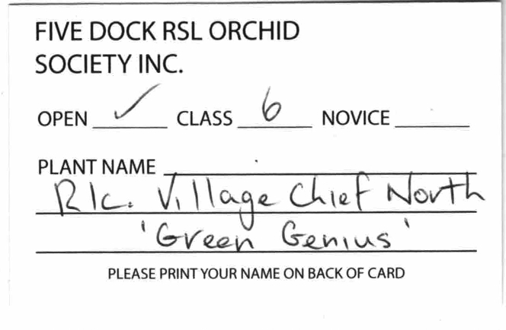

Put your name on the back of the card


Novice Section

If you are new to orchid growing, you can bench your plants in the Novice Section.
The Novice Classes are 37 – 47.
An example of a Novice description card – Novice Class 37 Cymbidium
Novice Class 37
Cymbidium

Your Cymbidium Cherry Cola ‘Greyserland’ would be filled out as below

Put your name on the back of the card
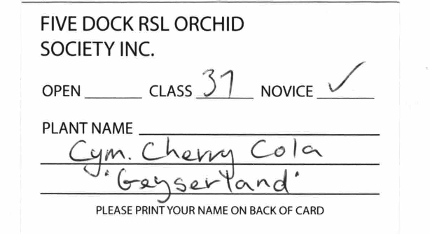

Points are given for each class with plants benched.
First Place – 5 points
Second Place – 3 points
Third Place – 1 point
All plants get one extra point for benching in a class.
If your Rlc. Village Chief North ‘Green Genius’ Benched in Class 6 Laeliinae (Cattleya)
5+ Flowers, got first place you would receive 6 points.
The Point Score is totalled each month for each class, and a grand total is calculated at the end of the year.
Five Dock year is from January to November – no meeting in December.
To qualify for a prize in the Open Section you need to have 10 points over the year.
There is an overall Open Champion – the member with the most points
There is also a Novice Champion – the Novice with the most points
A Novice is expected to advance to the Open Section when they either win the overall
Novice Points or is the Champion Novice in our Autumn or Spring Show.
We give out several trophies at the Prize Giving/Christmas Party.
The Trophy Prizes are,
Open Champion
Laeliinae Class 7a
Laeliinae Classes 3, 4, 5, 6, & 7b
Vandaceous & Phalaenopsis Classes 13, 14, 17, 18, 33 & 34
Dendrobium Classes 11 & 12
Australian Classes 30, 31 & 32
Australasian Classes 35 & 36
Novice Trophy
Novice Cymbidium
The member who wins the Growing Competition is also awarded a prize.

