Orchids Central

**Orchid Show & Sales**

**Club Condell Park**

**178 Eldridge Road**

**Bankstown**

***Club Bistro, Facilities and Parking***

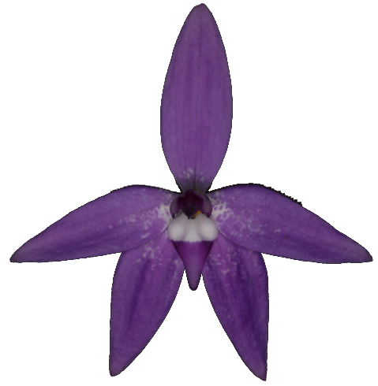

*Glossodia major* (Image Jim Cootes)

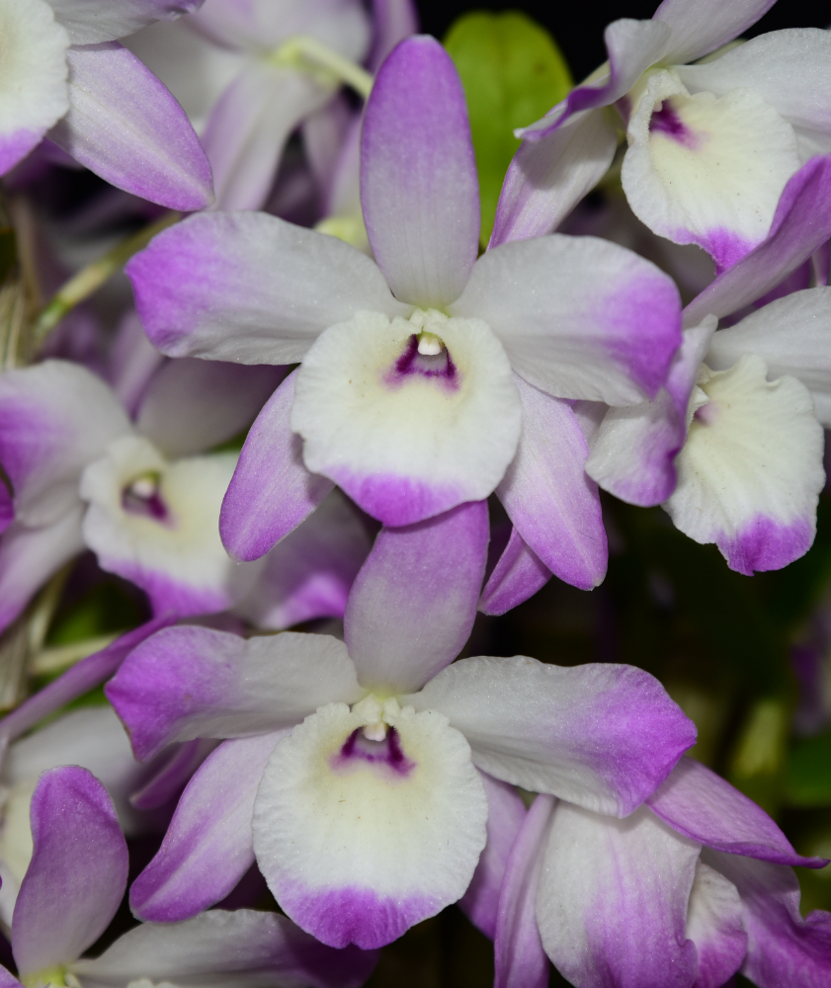

For more information email [orchids_central@mail.com](mailto:orchids_central@mail.com)

Website <http://www.orchidscentral.com.au> Facebook [Orchids central](https://www.facebook.com/groups/593167445614638/)

Friday 13th October 2023 9.30am – 4pm

Saturday 14th October 2023 9.30am – 4pm

Sunday 15th October 2023 9.30am – 2pm

**Admission $10 Children under 15 Free**

*Vendors*

* Alice’s Orchids (Qld)
* Bob Bishop Kiwi Orchid Bark (NSW)
* Dark Star Orchids (NSW)
* Ezi-Gro Orchids (WA)
* Foliage + (Qld)
* Fong Ping Orchids (Qld)
* Johnston’s Orchids (SA)
* Nicky’s Slippers (SA)
* Orchid Mania (Qld)
* Orchid Species Plus (Vic)
* Orchids of Distinction (Vic)
* Rolin Orchids (Qld)
* Sakdisri Nursery (Thailand)
* Sims Orchids (SA)
* Ten Shin Gardens (Taiwan)
* Tinonee Orchids (NSW)
* Western Orchids (SA)