FIVE DOCK RSL ORCHID SOCIETY INC SEPTEMBER 2026 BULLETIN
Meetings are held on the 4th Thursday in the months of January to November.
at Concord Community Centre, 1A Gipps Street, Concord, NSW 2137
The Society was founded on 19th July 1967.
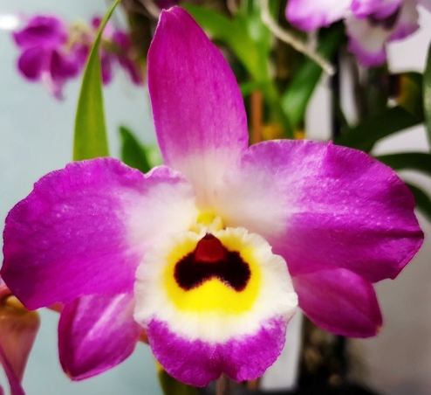
Society Emblem: Dendrobium Fivedock Fire ‘Summertime’
Next meeting will be held on Thursday 27th August 2026 commencing at 7.40 pm
Five Dock RSL Orchid Society is proudly supported by.
Club Five Dock RSL, Canada Bay Council and MarketPlace Leichhardt Shopping Centre
Visit our website www.fivedockorchids.com & our Facebook page Five Dock RSL Orchid Society for photos of the winning orchids from our Monthly Meetings and Annual Shows, Plants of the Night, Class winners, Show Champions, and record of our Social Events.
Website Coordinator: Jane D’Olier
PATRON: Robert Ridge
PRESIDENT: Fedora Pristov
VICE PRESIDENT: Kathy Koutsoukis
SECRETARY: Robert Moon Mobile: 0412 335 349
Society Email: fivedockrslos@yahoo.com.au
Postal Address: PO Box 4035, Bradbury NSW 2560
TREASURER: Fedora Pristov
SHOW MARSHAL Peter D’Olier
COMMITTEE: Jane D’Olier Sharon McIlwain Robyn McEwen
Peter D’Olier Merv Maher Jonathan Tran

President’s Report
Dear members
September has been a busy month. It’s repotting time!!

The second week in September we had our Spring Show at Leichhardt Marketplace, I wish to thank the members that benched plants and did duty, to Leichhardt Marketplace thank you for the support and assistance you have provided.

Congratulations to the following members: Philip La for benching the Grand Champion
Jonathan Tran for benching the Reserve Champion and George Yung for benching the Novice Champion, George will now be joining the Open Class next year.

Also, in September the Bunnings Spring Show at Rydalmere was attended by Jonathan, Kathy and myself, Jonathan did an exceptional job at repotting some plants and giving useful information to the customers.

As I write this report, we are at Orchids Central show, our display area was awarded a 1st in Class 2 Floor Display 6sqm, we give many thanks to Jonathan with the help of Thi who put the display together. To John Costa who received two 1st and two 2nds, to Philip La receiving one 2nd, Luisa and Sam who received a 2nd and lastly Jonathan who received two 1st and two 2nds
Congratulations, well done!

See you at our next meeting Fedora Pristov

FIVE DOCK RSL ORCHID SOCIETY INC
Minutes of the Monthly General Meeting held on 27th August 2026,
at Concord Community Centre, 1A Gipps Street, Concord
Opening:
The President declared the meeting open at 7.40pm and welcomed all members and our guest. Fedora then requested all those present to either turn their mobile phones off or to silent.

Apologies:
Apologies were as listed on the attendance sheet.

Minutes:
It was moved that Minutes of the meeting held on 23rd July 2026 as circulated, be adopted as a true and correct record of that night’s proceedings.
Moved George Yung Seconded Sheila Buchan Carried

Business arising:
There was no business arising from the minutes.

Treasurer’s Report:
Fedora tabled the treasurer’s report including accounts for payment
Moved John Costa Seconded Gavin Buchan Carried

Correspondence:
The summary of Correspondence received, was tabled. Consisting of various Orchid Society Newsletters, News on upcoming Orchid Events & Conferences, Open Gardens information from the Garden Clubs Australia and promotions of various “Orchid & Garden” tours.

General Business:
The President asked had everyone present had signed the attendance register for insurance purposes, Covid 19 tracing, and the lucky badge draw
Please support the Raffle
Fedora gave a report of the events for August including the display & talks and repotting demonstration at the 30th Anniversary of the Kokoda Track Memorial walkway & Ferragosto where we sold fertiliser & a raffle crowd numbers were down but we wish to give the executive for their assistance in providing the stall and special thanks to David Conway for all his help.
A reminder that our Spring show set up will be Wednesday 2nd September 2026 to Saturday 5th September 2026.
A further reminder that as one of the foundation societies of Orchids Central we need more volunteers to help not only on our duty day Saturday but fill holes in the roster on other days

Supper:
The meeting broke for Super

Lecture
We then were treated to a general discussion lead by Craig Scott Harden on Catasetums and their bi-sexual nature having different shaped flowers Which lead to some issues when naming based on flower morphology
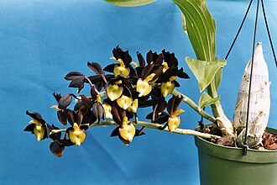 Male Flowers

Versus

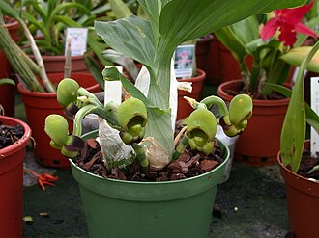 Female flowers

Theres was much joking about the “trigger” mechanism of the male flowers. With wild habitats usually located over ants’ nests to feed the orchid Nitrogen which they have heavy feeding requirements and are native to Mexico & South America and the West Indies centred on Brazil

Craig then mentioned their habitat requirements

Raffle:
Winners were Marianne Patchett, Sheila Buchan, Gavin Buchan, Judy Major, Lisa Harris, John Costa and Patrizia Massa

Closure:
The President then closed the meeting at 9.00 pm thanking members for helping supper, wished everyone a safe journey home, and asked for help to put the tables & Chairs away & vacuum up spilled potting media.

Beware of plants sold on eBay?

Recently there was a plant for sale on eBay, Den Fivedock Fire the name was split and the photo showed a plant with green in the outer labellum where in our emblem it is white but like all things if you look at the parents there is green in the labellum in one of the cultivars of the pollen parent

This is a time to remind members of our emblem. Dendrobium Fivedock Fire no that is not a misprint Fivedock is registered a one word. It was bred by Fred W Jones and Lloyd Woolnough in 2001 and yes, Lloyd was related to George Woolnough, the Tenterfield Saddler from the Peter Allen (born Peter Richard Woolnough) 1972 song about Peter’s grandfather and his life as the husband of Liza Minelli “the girl with an interesting face”.

The cross is Dendrobium Akatuki, as the seed parent, registered by Jiro Yamamoto in 1970 at the main nursery in Hamano, Okayama City, Japan they also have a branch nursery in Hawaii.
On 27th September 1978 the Cultivar ‘Queen’ was awarded an HCC in South Australia by the AOC award number 270.

The pollen parent was Dendrobium Shinonome another one of Jiro Yamaoto’s dendrobiums from 1975, none of the cultivars have been awarded thus far.

Den Fivedock Fire was used as the seed parent and was crossed in 2016 with Dendrobium Corona pollen parent to make Dendrobium Ziggy Stardust registered by Hills District Nursery. Obviously, David Banks must have been going through his “David Bowie” phase (Ziggy Stardust & the spiders from Mars)

So, the plant on eBay may be a Dendrobium Fivedock Fire despite being green as it may have been from one of its distant parents, Dendrobium findlayanum which has green in the labellum and makes about 15% of its parentage the majority 49% being from Dendrobium nobile.

Dates for the Diary
22nd October 2026 Monthly Meeting
08th November 2026 Manly Warringah Orchid Auction Cromer Community Centre
26th November 2026 Monthly Meeting / Growing Competition Judging
05th December 2026 Presentation Night / Christmas Party, Club Five Dock RSL
05th December 2026 Summer Orchid Festival, Georges Hall Community Centre Hall, 188 Birdwood Rd Georges Hall to 6th December 2026
28th January 2027 Monthly Meeting
25th February 2027 Monthly Meeting / Growing Competition Judging
09th March 2027 Friendship Night @ Club Five Dock RSL
19th March 2027 Royal Easter Show to 31st March 2027
25th March 2027 Monthly Meeting & AGM
22nd April 2027 Monthly Meeting
05th May 2027 Autumn Show Marketplace Leichhardt to 8/5/2027 To be confirmed
27th May 2027 Monthly Meeting / Growing Competition Judging
08th June 2027 Friendship Night @ Club Five Dock RSL
24th June 2027 Monthly Meeting
22nd July 2027 Monthly Meeting 60th Anniversary
15th August 2027 Ferragosto - Great North Rd five Dock “Street Fair”
26th August 2027 Monthly Meeting / Growing Competition Judging
02nd September 2027 Spring Show Marketplace Leichhardt to 5/092027 To be confirmed
07th September 2027 Friendship Night @ Club Five Dock RSL
14th September 2027 Orchids Central, Club Condell Park to 17th September 2027
23rd September 2027 Monthly Meeting
28th October 2027 Monthly Meeting
25th November 2027 Monthly Meeting / Growing Competition Judging
04th December 2027 Presentation Night / Christmas Party, Club Five Dock RSL

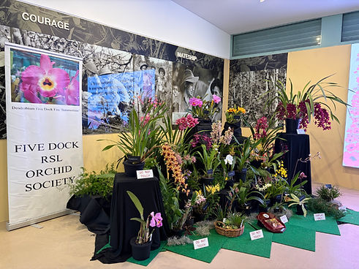
Five Dock RSL Orchid Society at the 30th Anniversary Kokoda Track Memorial Walkway, Concord 1st August 2026
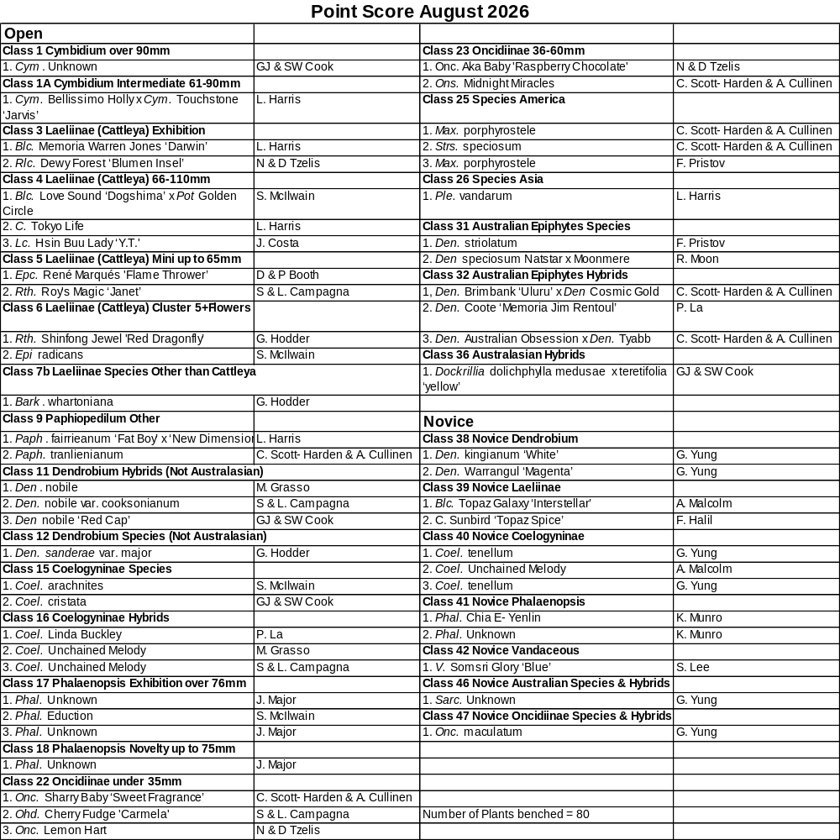

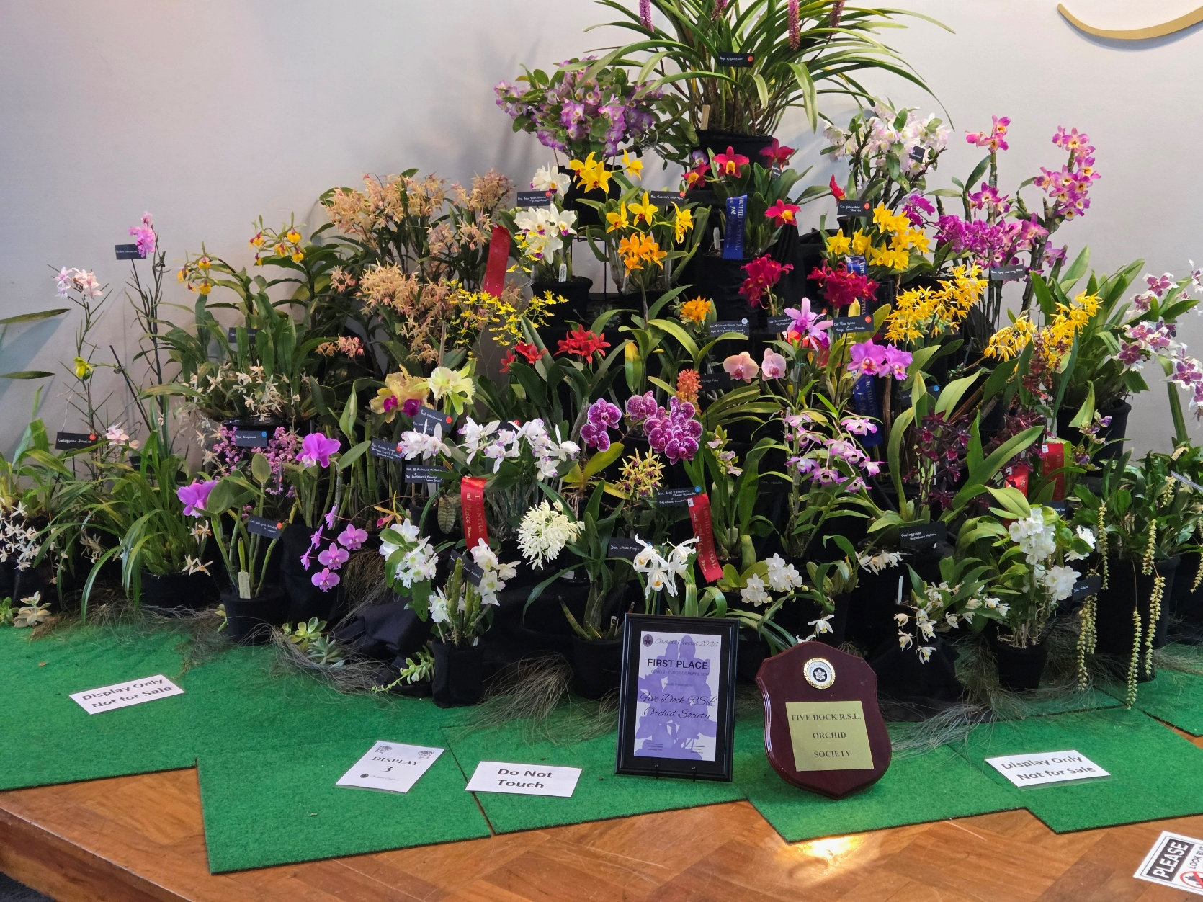

Five Dock RSL Orchid Society’s 1st Place in sectional
Display at Orchids Central Club Condell Park

