\\FIVE DOCK RSL ORCHID SOCIETY INC OCTOBER 2026 BULLETIN
Meetings are held on the 4th Thursday in the months of January to November.
at Concord Community Centre, 1A Gipps Street, Concord, NSW 2137
The Society was founded on 19th July 1967.
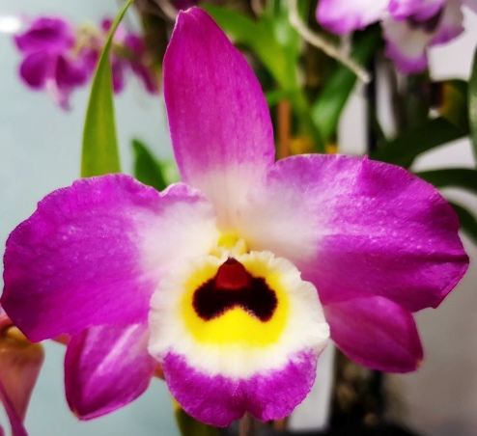
Society Emblem: Dendrobium Fivedock Fire ‘Summertime’
Next meeting will be held on Thursday 22nd October 2026 commencing at 7.40 pm
Five Dock RSL Orchid Society is proudly supported by.
Club Five Dock RSL, Canada Bay Council and MarketPlace Leichhardt Shopping Centre
Visit our website www.fivedockorchids.com & our Facebook page Five Dock RSL Orchid Society for photos of the winning orchids from our Monthly Meetings and Annual Shows, Plants of the Night, Class winners, Show Champions, and record of our Social Events.
Website Coordinator: Jane D’Olier
PATRON: Robert Ridge
PRESIDENT: Fedora Pristov
VICE PRESIDENT: Kathy Koutsoukis
SECRETARY: Robert Moon Mobile: 0412 335 349
Society Email: fivedockrslos@yahoo.com.au
Postal Address: PO Box 4035, Bradbury NSW 2560
TREASURER: Fedora Pristov
SHOW MARSHAL Peter D’Olier
COMMITTEE: Jane D’Olier Sharon McIlwain Robyn McEwen
Peter D’Olier Merv Maher Jonathan Tran

President’s Report
Dear members

The year is drawing to a close, and the committee will be discussing the menu for our Christmas/presentation night on 5 December this year. An exercise book will be placed on the main table for members to indicate if they will be attending the dinner, also please indicate dietary requirements and allergies.

All trophies that were presented in 2025 need to be brought in this month to allow updating for 2026.

October’s talk will be presented by Jan Robinson, the subject will be on Thunia, from previous talks by Jan this should be highly informative and entertaining

November’s talk will relate to benching in our monthly meetings, this will include how to fill in benching cards, understanding classes and why there is a point score for plants benched.

See you at our meeting on Thursday Fedora Pristov

FIVE DOCK RSL ORCHID SOCIETY INC
Minutes of the Monthly General Meeting held on 24th September 2026,
at Concord Community Centre, 1A Gipps Street, Concord
Opening:
The President declared the meeting open at 7.40pm and welcomed all members and our guest. Fedora then requested all those present to either turn their mobile phones off or to silent.

Apologies:
Apologies were as listed on the attendance sheet.

Minutes:
It was moved that Minutes of the meeting held on 27th August 2026 as circulated, be adopted as a true and correct record of that night’s proceedings. It was noted the date of the meeting was incorrectly shown
Moved Luisa Campagna Seconded George Yung Carried

Business arising:
There was no business arising from the minutes.

Treasurer’s Report:
Fedora tabled the treasurer’s report including accounts for payment
Moved Marianna Patchett Seconded Sam Campagna Carried

Correspondence:
The summary of email correspondence received, was tabled. Consisting of various Orchid Society Newsletters, News on upcoming Orchid Events & Conferences, Open Gardens information from the Garden Clubs Australia and promotions of various “Orchid & Garden” tours.

General Business:
The President asked had everyone present had signed the attendance register for insurance purposes, Covid 19 tracing, and the lucky badge draw
Please support the Raffle
Fedora presented the prize & plant sales money to our members and gave a short wrap up of the show
Bunnings Spring launch speakers were Kathy & Fedora with Jonathan giving a potting demonstration
Prize money from Orchids Central was distributed to the winners

Supper:
The meeting broke for Super

Lecture
Fedora Introduced our Guest Speaker Graham Russell an ANOS Judge and member of Cumberland Orchid Circle. His presentation was on Dendrobium Speciosum.
Graham started by advising he originally grew Cymbidiums which made up about 20% of his collection. Then about 15 years ago he started collecting Native Dendrobiums & Sarcochilus. Then hard cane SE Asian Dendrobiums, which he grows near his pool and shades with 50% shadecloth in summer.
He was mentored by Joe Gaffer who had extensive orchid knowledge advising Light, light & more light to grow orchids. Bill Dobson was also mentioned.
In 2010-12 while completing the ANOS Judging course which was held at Gerry Walsh’s home as it was then at Llandilo every 2 months, he bought seedling from Gerry

The nine varieties of Dendrobium speciosum currently are: -

Dendrobium speciosum var. speciosum
Dendrobium speciosum var. boreale
Dendrobium speciosum var. carnarvonense
Dendrobium speciosum var. grandiflorum
Dendrobium speciosum var. pedunculatum
Dendrobium speciosum var. blackdownense
Dendrobium speciosum var. capricornicum
Dendrobium speciosum var. curvicaule
Dendrobium speciosum var. hillii

Graham did not subscribe to the ‘Jones/Clements’ approach of some twelve distinct species

He showed some of the tricks he uses such as cups over leaf crow to prevent water build up & crown rot
Graham then proceeded to give a potting demonstration of how he repots speciosum
Graham stressed the need for sterile instruments and used rubber gloves
For pots he uses 250ml which he advised were ideal due to their extra depth. Before reusing pots, he cleans with a strong bleach solution
His mix includes 12-18 grade Bark (for larger plants) Mix of 9-12& 12-15 Bark (for smaller plants) River Pebbles, Polystyrene & Clay balls and Scoria Graham noted he gets his polystyrene from building site waste
He removes all roots as new roots will come from the pseudobulb Remember to sterilise cutting tools between uses especial different plants. Remove dead canes when dividing you should see natural divisions. He especially noted to be VERY!! Careful of new growths especially when removing roots. Seal all cuts with steriprune or cinnamon. Place all rubbish in a sealed plastic bag in Rubbish bin NOT green waste recycling bin. He noted new growth should face the centre of the pot and stake & tie the canes to be secure in the pot as there are no roots to be held in the bark media. Graham finished the dressing with a Confidor tablet, slow-release fertiliser & either Dynamic Lifter or Seamungus pellets top layer of 3-6 grade bark to top off the pot. His final is to use the “Bill’s Majic Mix” from University of California mixture of Hoof & Horn Potassium Nitrate. Potassium Sulphate, Dolomite etc. In the bark he adds Oxyone Rooting hormone for root growth. Healthy roots healthy plant. Last item is to label the plant.

Fedora thanked Graham for his presentation

Lucky Badge draw
Was won by Philip La

Raffle:
Winners were Phillip La, John Costa, Fazil Halil (x2), Robyn McEwen, Sam Campagna (x2), Karen Munro, Ingrid Allan, Anne Malcolm & Robert Moon.

Closure:
The President then closed the meeting at 9.40 pm thanking members for helping with supper, wished everyone a safe journey home, and asked for help to put the tables & Chairs away & vacuum up spilled potting media.

Dates for the Diary

08th November 2026 Manly Warringah Orchid Auction Cromer Community Centre
26th November 2026 Monthly Meeting / Growing Competition Judging
05th December 2026 Presentation Night / Christmas Party, Club Five Dock RSL
05th December 2026 Summer Orchid Festival, Georges Hall Community Centre Hall, 188 Birdwood Rd Georges Hall to 6th December 2026
28th January 2027 Monthly Meeting
25th February 2027 Monthly Meeting / Growing Competition Judging
09th March 2027 Friendship Night @ Club Five Dock RSL
19th March 2027 Royal Easter Show to 31st March 2027
25th March 2027 Monthly Meeting & AGM
22nd April 2027 Monthly Meeting
05th May 2027 Autumn Show Marketplace Leichhardt to 8/5/2027 To be confirmed
13th May 2027 Orchids Out West Philip Charley Pavilion, Hawkesbury Showground, Clarendon set up from 10am to 16th May 2027
27th May 2027 Monthly Meeting / Growing Competition Judging
08th June 2027 Friendship Night @ Club Five Dock RSL
24th June 2027 Monthly Meeting
22nd July 2027 Monthly Meeting 60th Anniversary
15th August 2027 Ferragosto - Great North Rd Five Dock “Street Fair”
26th August 2027 Monthly Meeting / Growing Competition Judging
02nd September 2027 Spring Show Marketplace Leichhardt to 5/092027 To be confirmed
07th September 2027 Friendship Night @ Club Five Dock RSL
23rd September 2027 Monthly Meeting
14th October 2027 Orchids Central, Club Condell Park to 17th October 2027
28th October 2027 Monthly Meeting
25th November 2027 Monthly Meeting / Growing Competition Judging
04th December 2027 Presentation Night / Christmas Party, Club Five Dock RSL

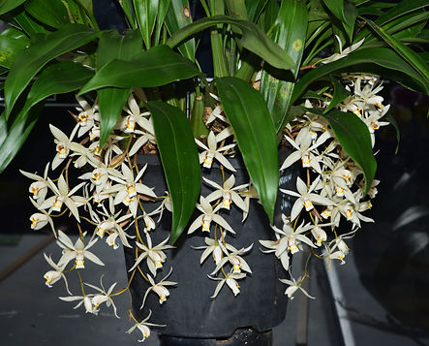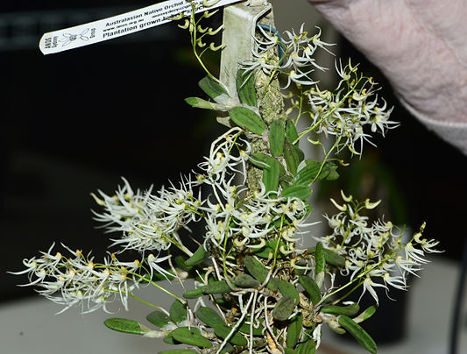

Open Plant of the Night Novice Plant of the Night
Dendrobium linguiforme Coelogyne flaccida
Owned by Robert Moon Owned by George Yung

Dendrobium linguiforme was first formally described in 1800 by Swedish botanist Olof Peter Swartz (Born in Norrköping, Sweden on 21st September 1760 – Died at Stockholm, Sweden 19th September 1818) published in Kongliga Vetenskaps Academiens Nya Handlingar. In 1981, Friedrich Gustav Brieger (Born in Wrocław, Poland (AKA Breslau, Silesia) on 11th October 1900 – Died in Bad Dürrheim, Baden-Württemberg Germany on 6th February 1985) he was a German-born Brazilian botanist who transferred the species to Dockrillia as D. linguiformis but the name has not been accepted. The specific epithet (linguiforme) is derived from the Latin words lingua meaning "tongue" and forma meaning "shape"
The species occurs in New South Wales and Queensland where it grows on rocks and trees, usually in sclerophyll forest and sometimes in rainforest or in rocky places. In New South Wales it occurs on the coast and tablelands north of Ulladulla and inland as far as Gungal and Tamworth. In Queensland it is found from the Atherton Tableland to Townsville and south from Gympie to the New South Wales border.

Point Score September 2026
Open
Class 2 Cymbidium Miniature up to 60mm |  | Class 22 Oncidiinae under 35mm
1. Cym. Gumnut Imp ‘Peter’ | R. Oppedisano | 1. Onc. Unknown | S & L. Campagna
Class 3 Laeliinae (Cattleya) Exhibition |  | Class 23 Oncidiinae 36-60mm
1. Rlc. Triumphal Coronation 'Seto' | P. La | 1. Ons. Pearberry ‘Eye Candy’ | P. La
2. C. Mildred Rives x Princess Bells ‘Sally’ | D & P Booth | 2. Onc. Cherry Fudge ‘Carmela’ | S & L. Campagna
3. C. Cariad's Mini-Quinee 'Angle Kiss’ | S. McIlwain | 3. Onc Firecat ‘Highlight’ | S & L. Campagna
Class 4 Laeliinae (Cattleya) 66-110mm |  | Class 24 Oncidiinae over 61mm
1. Rlc. Swan’s Lolly ‘Topaz Velvet’ | P. La | 1. Ons. Tiger Barb | J. Costa
2. C. Mini Jewel | S & L. Campagna | 2.Alcra. Winter Wonderland 'White Fairy' | S & L. Campagna
3. Bc. Morning Glory ‘H&R’ | J. Tran | Class 25 Species America
Class 5 Laeliinae (Cattleya) Mini up to 65mm |  | 1. Coelia triptera, | P & J D’Olier
1. C. Flava-Psyche | P & J D’Olier | Class 31 Australian Epiphytes Species
Class 6 Laeliinae (Cattleya) Cluster 5+Flowers |  | 1. Den. linguiforme | R. Moon
1. C. Trick or Treat | J. Tran | 2. Den. schoeninum | R. Moon
2. Lc. Aussie Sunset ‘Cosmic Fire’ x Lc Trick or Treat ‘Orange Beauty | K. Koutsoukis | 3. Den. teretifolium | R. Moon
Class 7a Laeliinae (Cattleya) Species |  | Class 32 Australian Epiphytes Hybrids
1. C. neokautskyi | P & J D’Olier | 1. Den. Kingianum | S & L. Campagna
Class 7b Laeliinae Species Other than Cattleya |  | Class 36 Australasian Hybrids
1, Epi. Unknown | T. Balgos & S Thompson | 1. Den. Red Dame x canaliculatum | P & J D’Olier
Class 10 Cypripedioideae Species
1. Paph delenatii var alba | S. McIlwain | Novice
2. Paph argus | S. McIlwain | Class 38 Novice Dendrobium
Class 11 Dendrobium Hybrids (Not Australasian) |  | 1. Den. Swallow Queen | F. Halil
1. Den. Hamana Lake Dream x Sailor Boy x Popeye | J. Costa | 2. Den Unknown | F. Halil
2. Den. Yukidaruma 'The King' | G. Hodder | Class 39 Novice Laeliinae
3. Den. Fortune H | G. Hodder | 1. Epi. Candy Valley #1 | K. Munro
Class 12 Dendrobium Species (Not Australasian) |  | 2. C. Unknown | F. Halil
1. Den. moliforme ‘Tsubski’ x moliforme ‘Tsubski’ | S. McIlwain | 3. Ctt. Doris & Byron ‘Christmas Rose’ | F. Halil
Class 13 Monopodial/Vandaceous Species |  | Class 40 Novice Coelogyninae
1. Phal. schilleriana | S. McIlwain | 1. Coel. flaccida | G. Yung
Class 15 Coelogyninae Species |  | Class 41 Novice Phalaenopsis
1. Coel. lawernciana | S. McIlwain | 1. Phal. Unknown | D. Gillon
2. Coel. flaccida | R. Oppedisano | 2. Phal. Unknown | D. Gillon
3. Coel. longiarchis | P & J D’Olier | 3. Phal. Unknown | D. Gillon
Class 17 Phalaenopsis Exhibition over 76mm |  | Class 44 Novice Misc. Hybrids Not Listed
1. Phal. Unknown | J. Major | 1. Zga. Happy Bay ‘Green Hills’ x Npp Beverley Lou Stripes | A. Malcom
2. Phal. Unknown | J. Major | Class 46 Novice Australian Species & Hybrids
3. Phal. Unknown | J. Major | 1. Sarco. Kulnura Sprint ‘Super Blotch’ x Kulnura Harrow Extreme | M. Griffiths
Class 18 Phalaenopsis Novelty up to 75mm |  | 2. Sarc. Kulnura Drive ‘4 Black’ x Kulnura Dazzle ‘Deep Velvet’ | K. Munro
1. Phal. Unknown | S. McIlwain
 |  | No of Plants Benched = 79

